***Implementation of Regular Expressions:***

**Code: Case 1:**

package regex;

import java.util.regex.*;

public class regex1 {

public static void main(String[] args) {

String pattern = "[a-z]+";

String check = "HI THIS IS ME";

//String check = "HITHISISme hello How Are you?";

Pattern p = Pattern.compile(pattern);

Matcher c = p.matcher(check);

if(c.find())

System.out.println("The Match is"+check.substring( c.start(), c.end() ) );

else {

System.out.println("There is no perfect match");

}

}

}

**Output:**

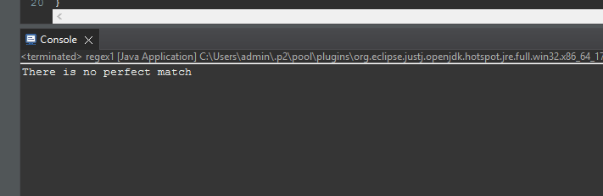

**Code: Case 2:**

package regex;

import java.util.regex.*;

public class regex1 {

public static void main(String[] args) {

String pattern = "[a-z]+";

//String check = "HITHISISME";

String check = "HITHISIS me hello How Are you?";

Pattern p = Pattern.compile(pattern);

Matcher c = p.matcher(check);

if(c.find()) {

System.out.println("The perfect match is");

while(c.find()) {

System.out.println(check.substring( c.start(), c.end() ) );

}

}

else {

System.out.println("There is no perfect match");

}

}

}

**Output:**

